# Completing MyOpinions Survey Step-by-Step

## Points: 50 Topic: Business & Employment Time required: 5mins Total steps from (clicking start survey to clicking "go to my account" link): 26

1. Navigate to <https://www.myopinions.com.au/auth/dashboard>

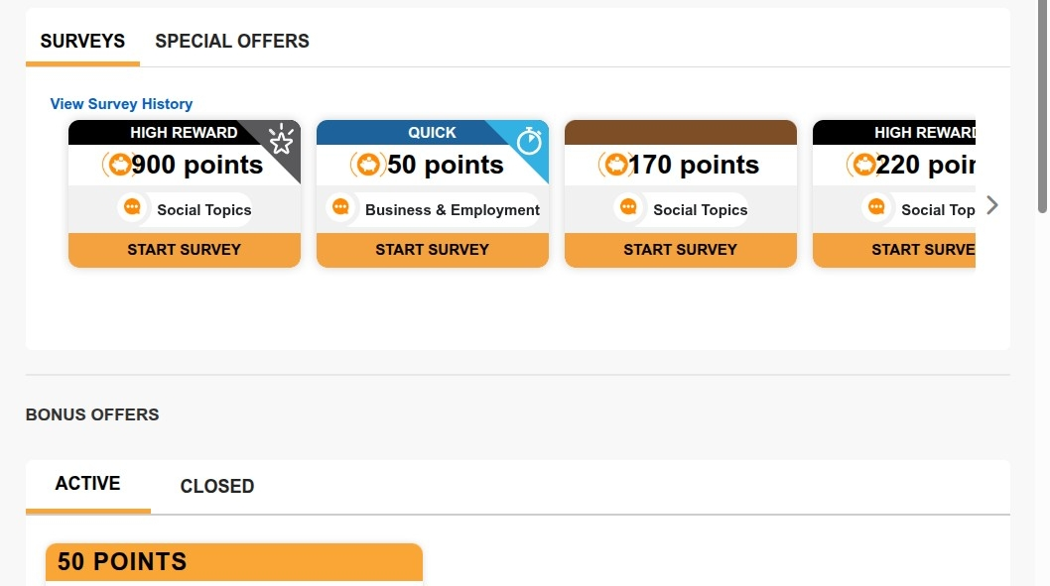

1. Click "START SURVEY"

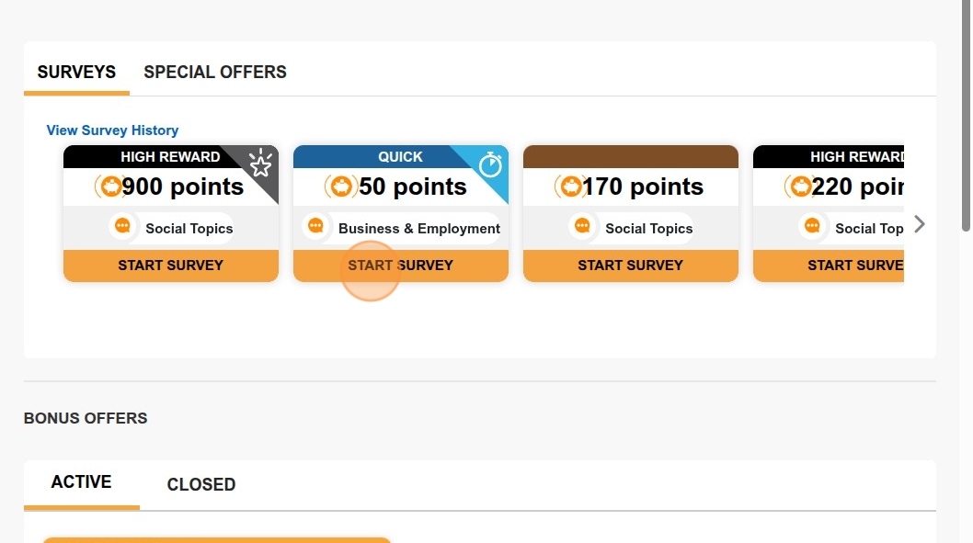

1. Click "START SURVEY NOW"

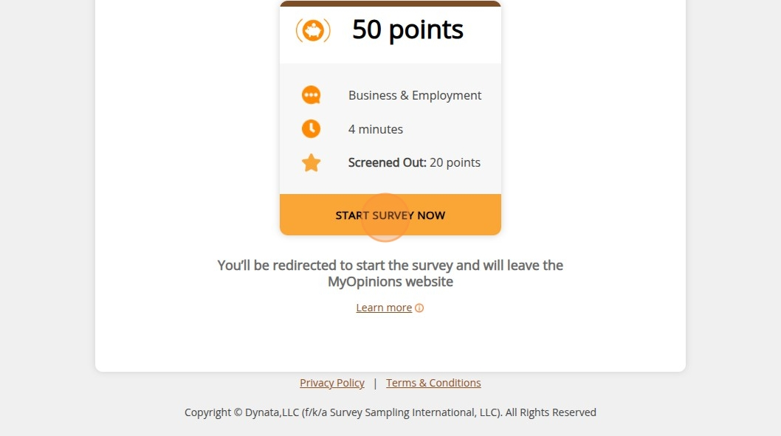

1. Are you.. ?
   1. Click this image.
   2. Note: in this survey Gender selection choice was an image rather than a radio button or text typing

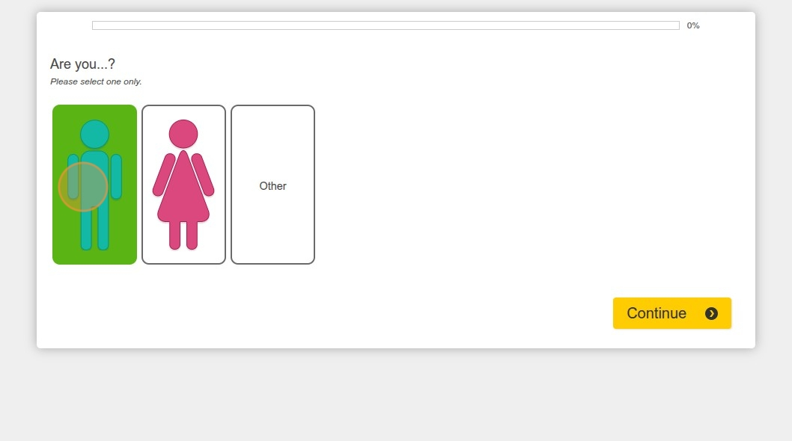

1. Click this button.

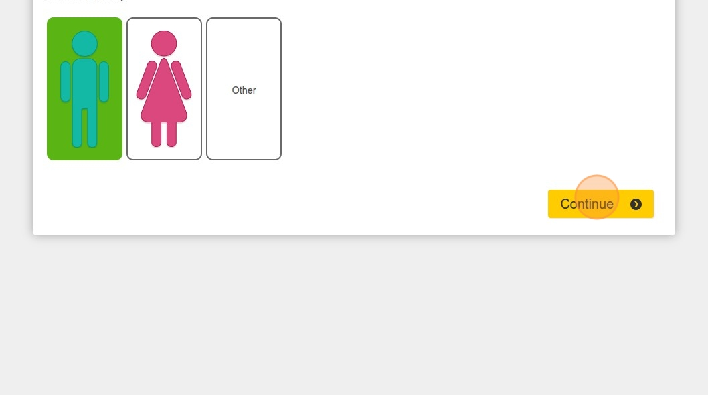

1. Click this text field.

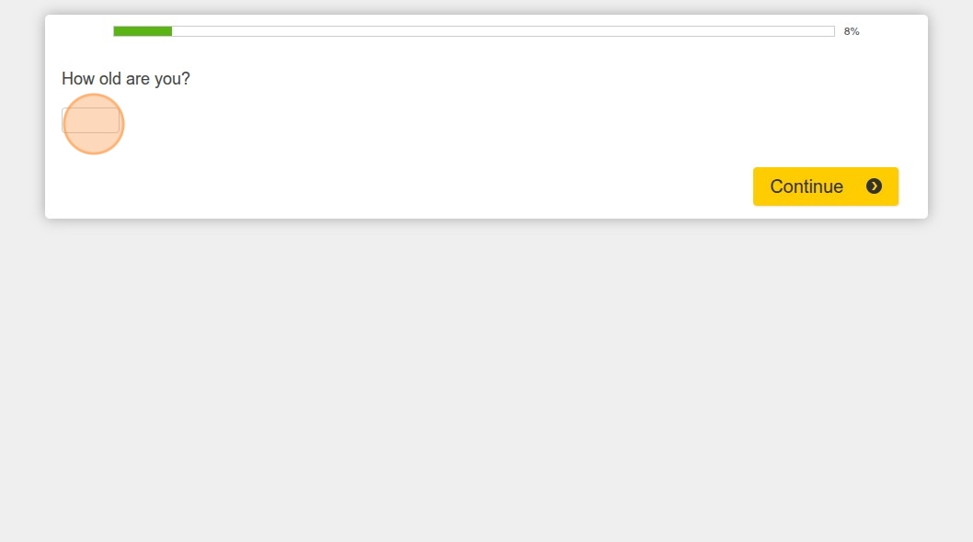

1. Type "45"
2. Click this button.

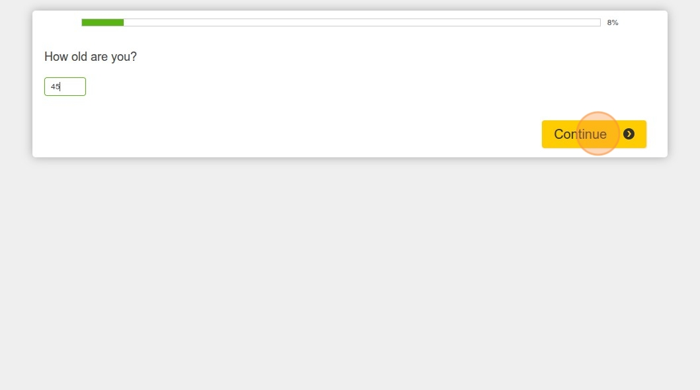

1. Click this text field.

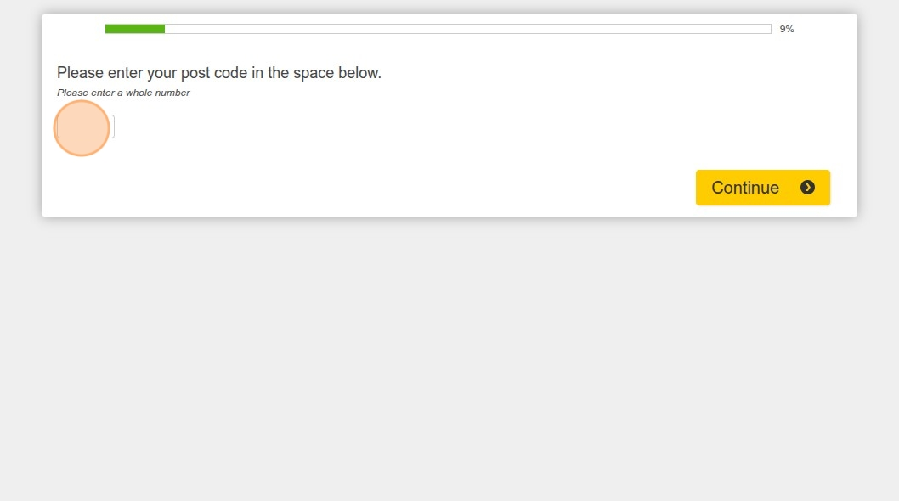

1. Type "212"
2. Click this text field.

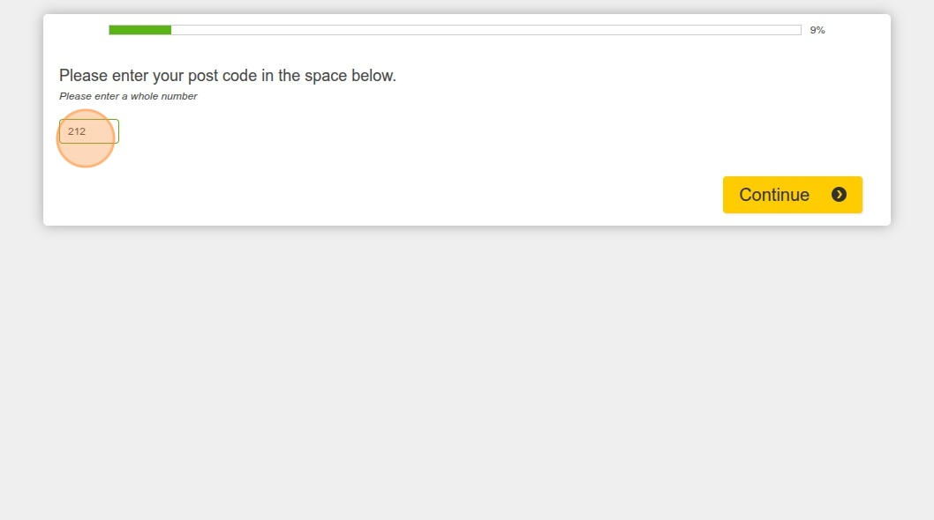

1. Click this text field.

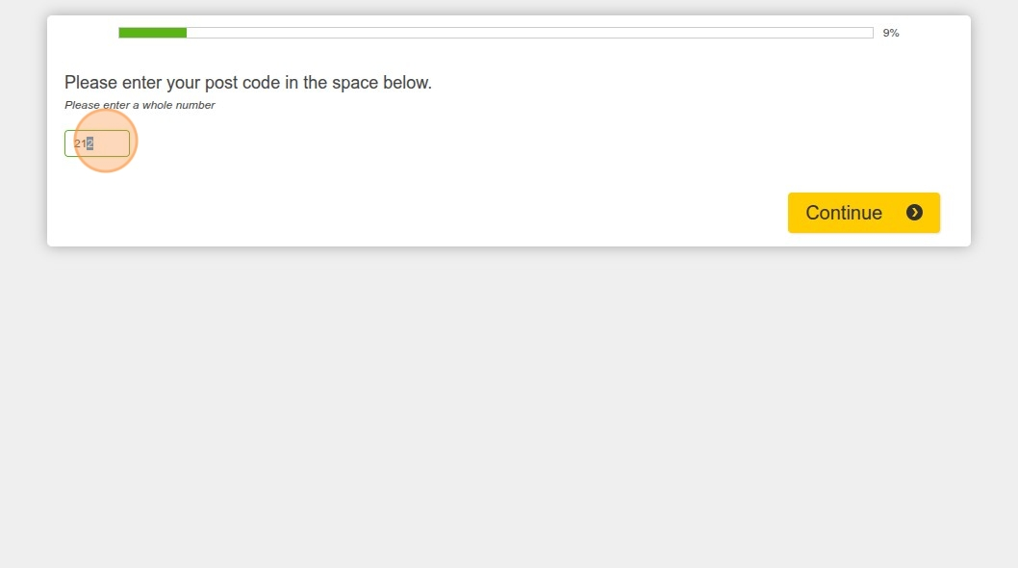

1. Type "2217"
2. Click this button.

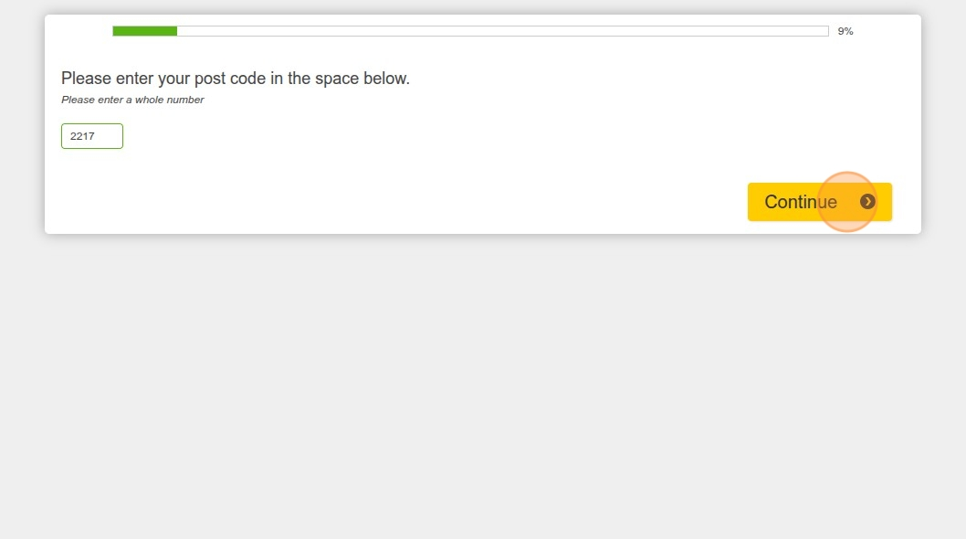

1. Click this icon.

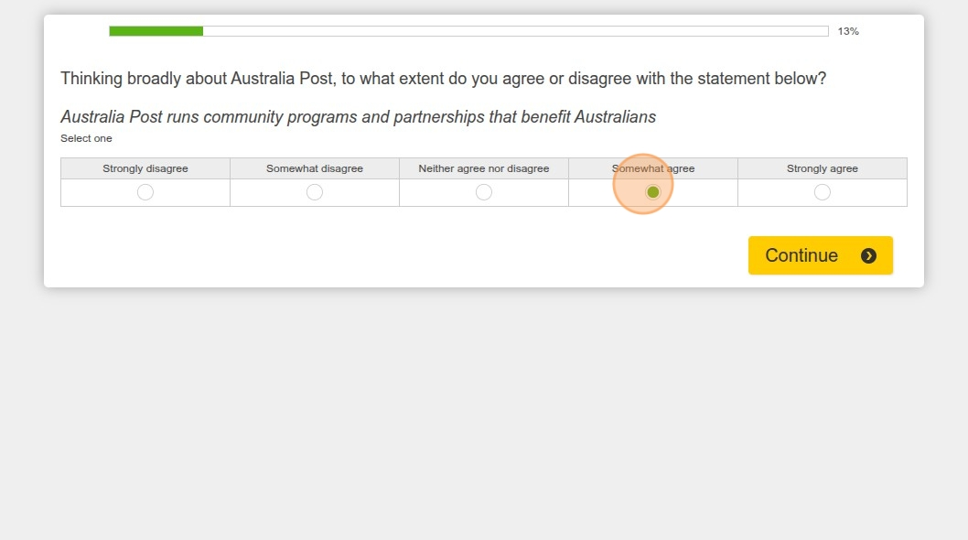

1. Click this button.

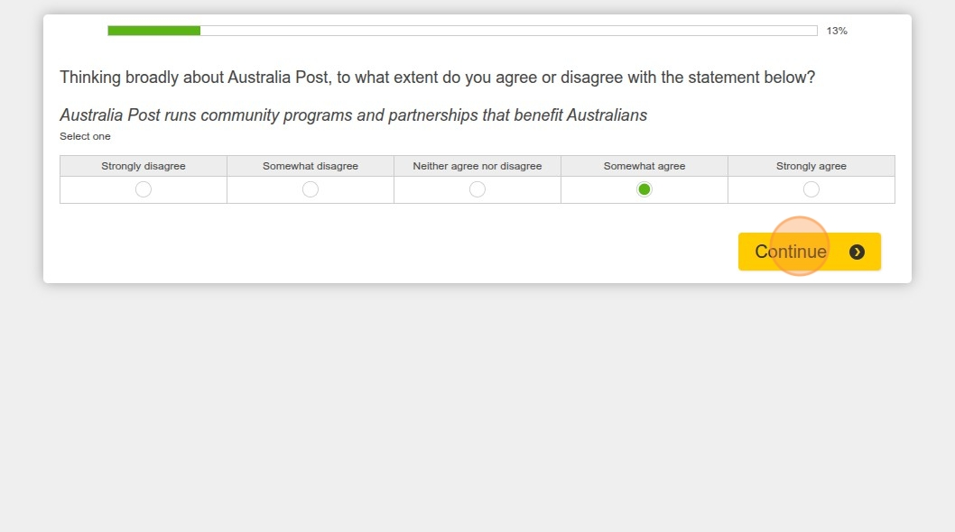

1. Click this button.

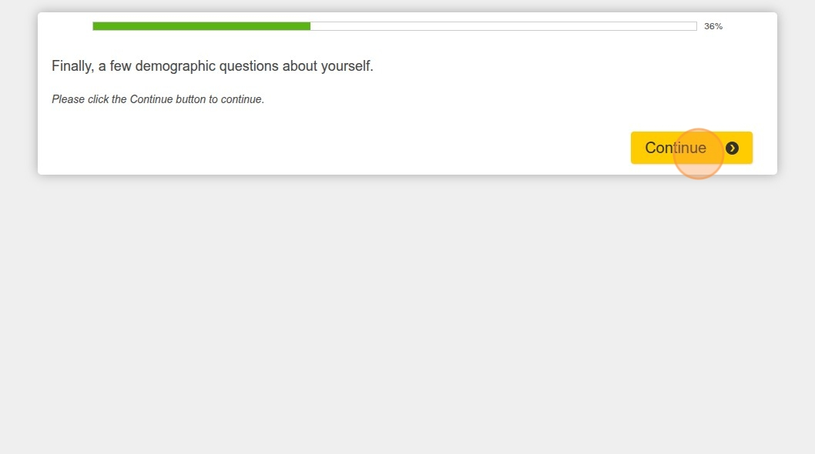

1. What is your annual gross (i.e. before tax) household income range?
   1. Click "$200,000 to $499,999 AUD"

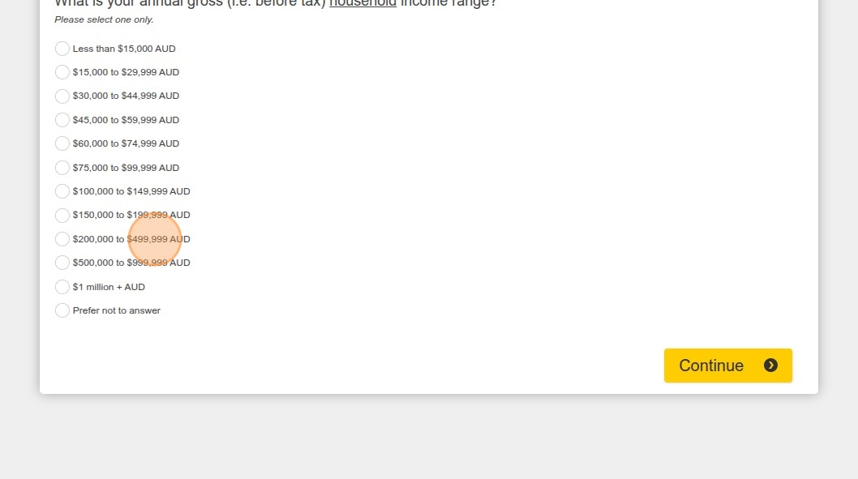

1. Click this button.

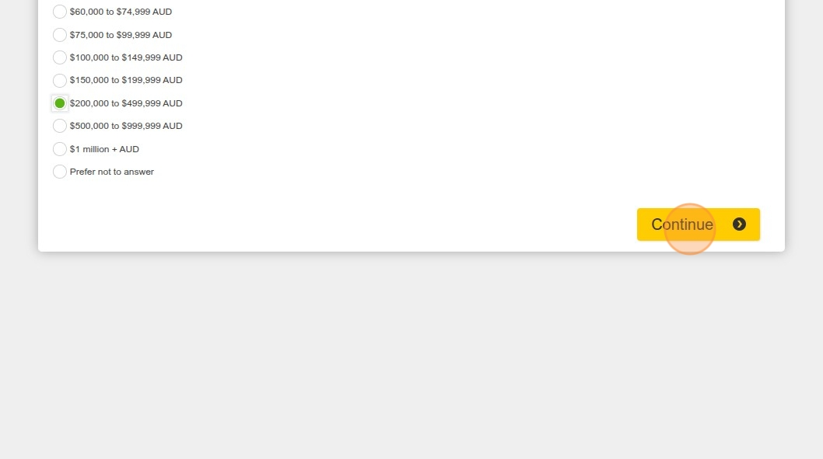

1. What is your annual gross (i.e. before tax) personal income range?
   1. Click "$100,000 to $149,999 AUD"

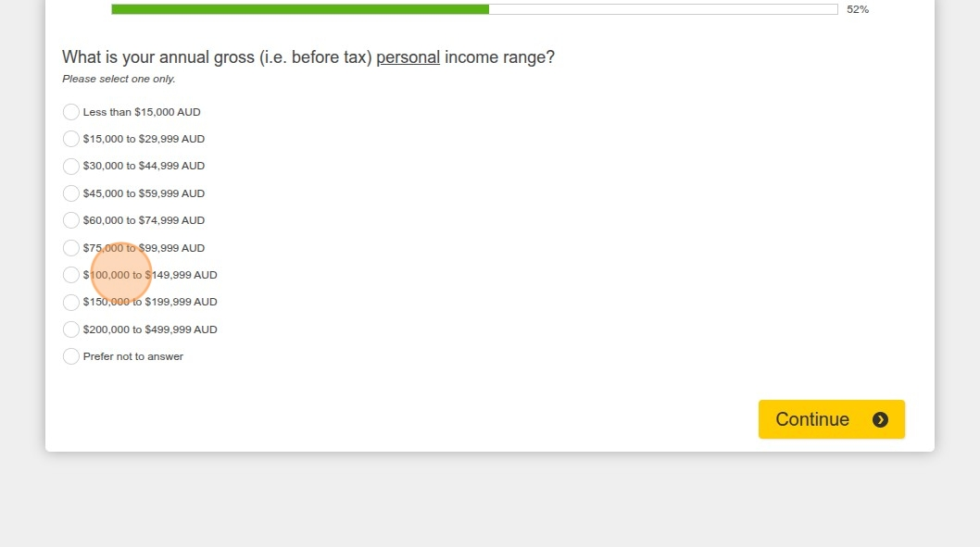

1. Click this button.

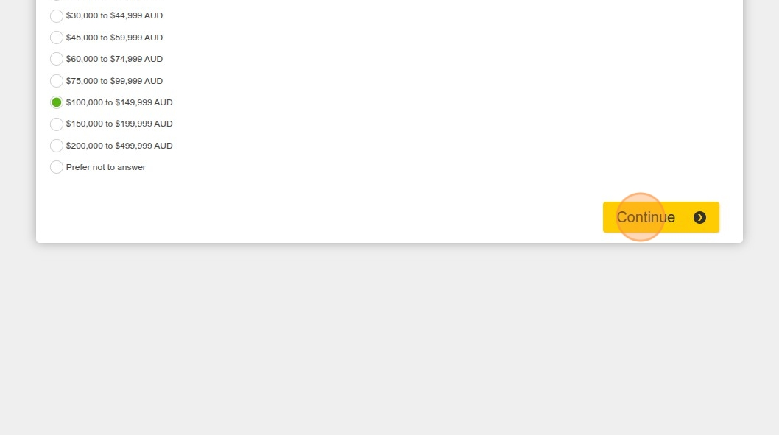

1. Click "Parent/guardian, with the youngest child aged 3-12 years living with me"

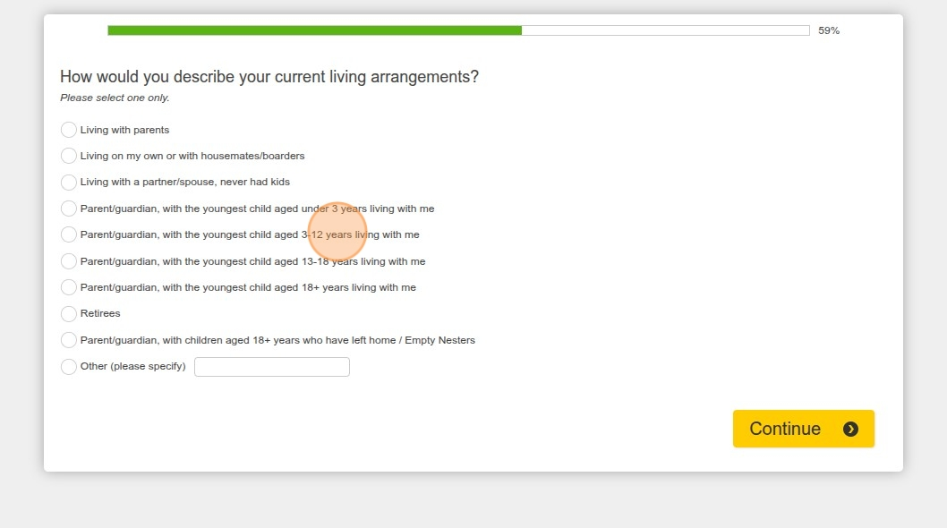

1. Click this button.

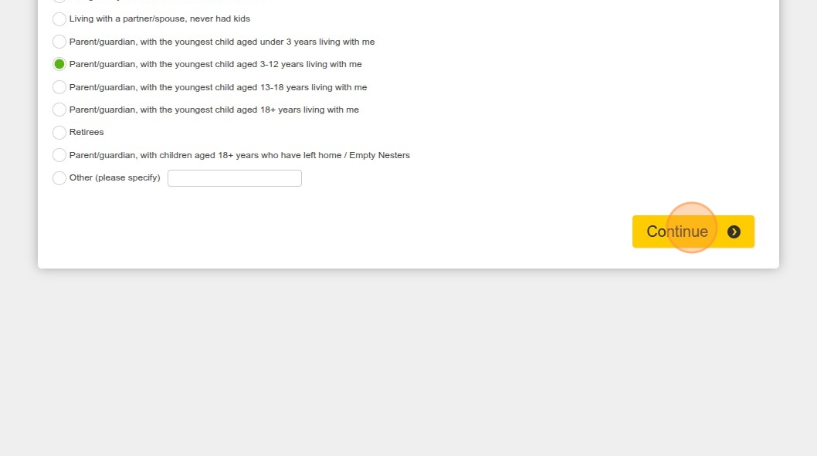

1. Click "Full-time (30 or more hours per week)"

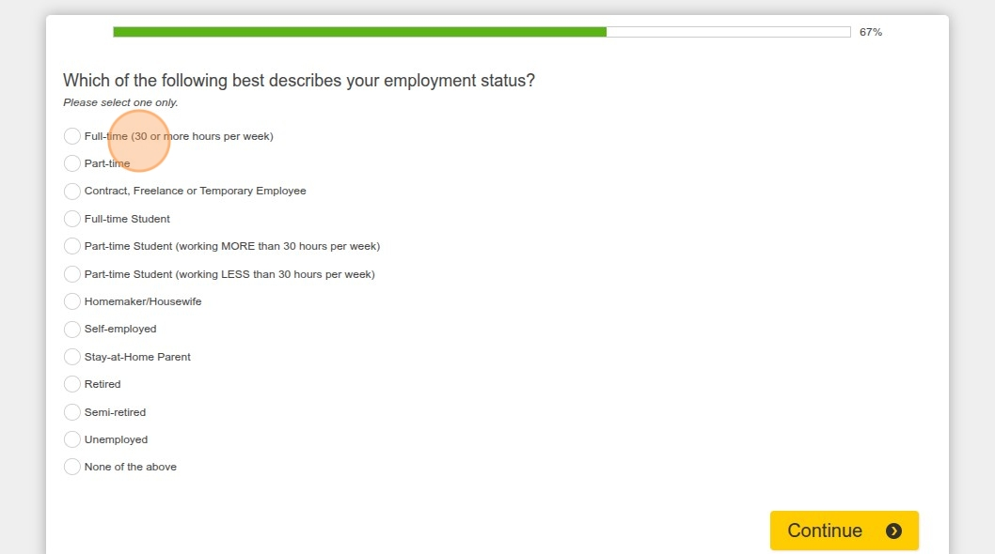

1. Click this button.

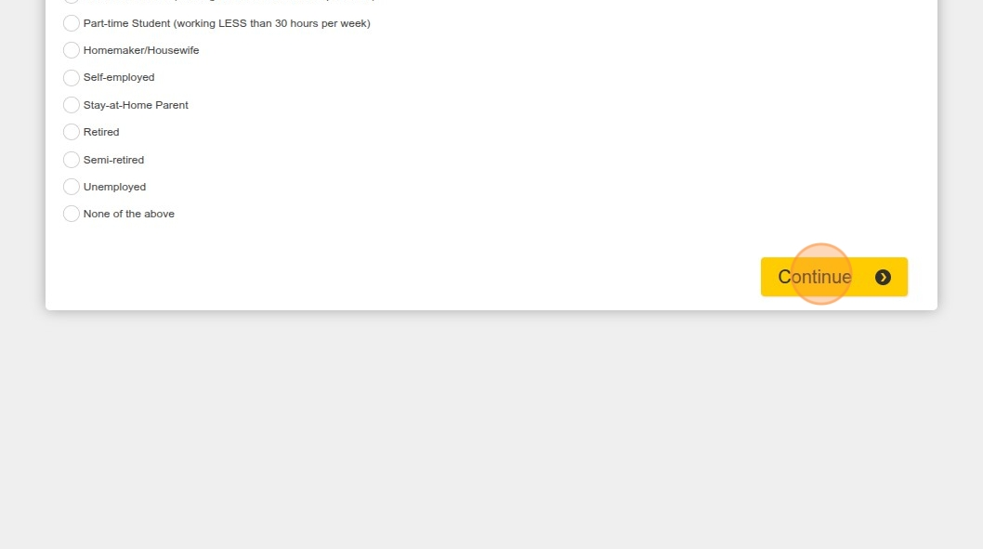

1. Click "Go to my account"

